Logbook 3 (for offline log preparation)
Name: | Yvette Lee EnQi
Week Date: | Part A -Meeting 3 of 8
(The above information is for you to keep track of which week this log is applicable for. This information is not required in the online logbook as the system will find your name, your supervisor’s name, and take the submission date, automatically. You must submit the online log in the relevant week. Logs cannot be backdated to missed weeks.)

Meeting date:  (please note if no meeting is planned this week) | 02/07/2026
Work Undertaken this week:  (No more than 4000 characters, including spaces) | - Following feedback from Meeting 2, I restructured the robot design for outdoor operation. This relaxes the width constraint from <19 cm to <25 cm and increases ground clearance to >3 cm for soil-bed row spacing (~0.3–0.6 m). I have decided to proceed with a custom 3D-printed chassis rather than the TurtleBot3 Burger, as this allows better camera mounting flexibility and ground clearance for outdoor terrain.  - I began the chassis design in CoppeliaSim (robot simulation environment) to visualise the overall robot layout and rough sensor placement before committing to the physical CAD model. The simulated model includes a differential-drive base, downward-facing camera mast, GNSS antenna mount, and two forward-facing promxity sensors. This helped validate the mechanical proportions and centre-of-gravity estimate before Tinkercad modelling.  - I also began a preliminary Tinkercad CAD sketch: 200 mm × 220 mm × 3 mm base plate, four motor mounting positions, central battery tray, and camera mast with sun shield. The design is preliminary and will be refined once exact motor dimensions are confirmed.  - I searched online for the weights as I didn’t have the actual components. The Raspberry Pi 5 is 85 g and Pi Camera Module 3 is 10 g. Remaining components were estimated from manufacturer datasheets: Coral USB TPU ~35 g, 11.1V LiPo 5000 mAh ~300 g, DC motors ~80 g each, motor driver ~50 g, ultrasonic sensors ~20 g each, PETG chassis ~150 g. Total estimated weight: ~1.1 kg (well under the 3 kg outdoor target).  - At the July 2 meeting, the supervisor suggested using transfer learning for the AI model. I will use a MobileNetV3 model pre-trained on ImageNet and fine-tune the final classification layers on a plant health dataset. This reduces training time and improves accuracy with limited data, which is ideal for the Raspberry Pi 5's compute constraints.  - I also investigated BabyROS as a lightweight alternative to standard ROS2. However, I found it lacks support for the nav2 navigation stack and robot_localization EKF fusion required for outdoor GNSS waypoint following. I will proceed with standard ROS2 Humble for the core architecture, which has proven compatibility with differential-drive agricultural robots and extensive community support.
Problems encountered:  (No more than 4000 characters, including spaces) | - Weather resistance: The robot must operate outdoors in Singapore's tropical climate (rain, humidity, dust). I need to design an IP54-rated electronics enclosure for the Raspberry Pi and battery and determine whether PETG chassis parts require sealing or if a separate waterproof box is needed.  - CAD inexperience: I am new to CoppeliaSim and designing a full prototype by myself. The simulation and sketch are preliminary and need exact motor hole spacing and structural validation.  - Component access: I do not yet have physical motors, motor drivers, or the GNSS module to weigh them or verify mounting dimensions. Procurement is on hold pending supervisor approval of the Project Outline.  - GNSS accuracy: Standard GPS modules (NEO-M8N) have 3–5 m accuracy, which may be too coarse for 0.3 m row spacing. I need to determine whether the budget can accommodate an RTK module or if visual row-following backup is required.  - BabyROS unsuitable: Confirmed it lacks nav2 and EKF support. Decision made to use standard ROS2 Humble.
Tasks agreed for upcoming week:  (No more than 4000 characters, including spaces) | - Refine the chassis model with exact motor mount hole spacing, battery retention clips, and camera mast angle. Export a dimensioned 2D drawing.  - Complete the Project Outline draft (target: 90% complete) and submit to supervisor for formal review and procurement approval.  - Research transfer learning implementation: identify pre-trained MobileNetV3 checkpoints (PyTorch/TensorFlow), dataset requirements for fine-tuning, and inference pipeline on Raspberry Pi 5 + TFLite.  - Confirm component list with supervisor: specific motor model, motor driver, GNSS module, and ultrasonic sensor model available in lab inventory or approved for purchase.  - Set up ROS2 Humble development environment on laptop and run turtlebot3_gazebo simulation to begin understanding nav2 waypoint following parameters.  - Do not procure any parts until the supervisor has approved the Project Outline and scope.
Figures:  (Upload image files in the online Log Form, but feel free to keep notes here about which images you intend to upload. Use “Figure Caption” information as the filenames, e.g., “Figure 1 – A screenshot of the initial constrained Sketch in CATIA.jpg”) | 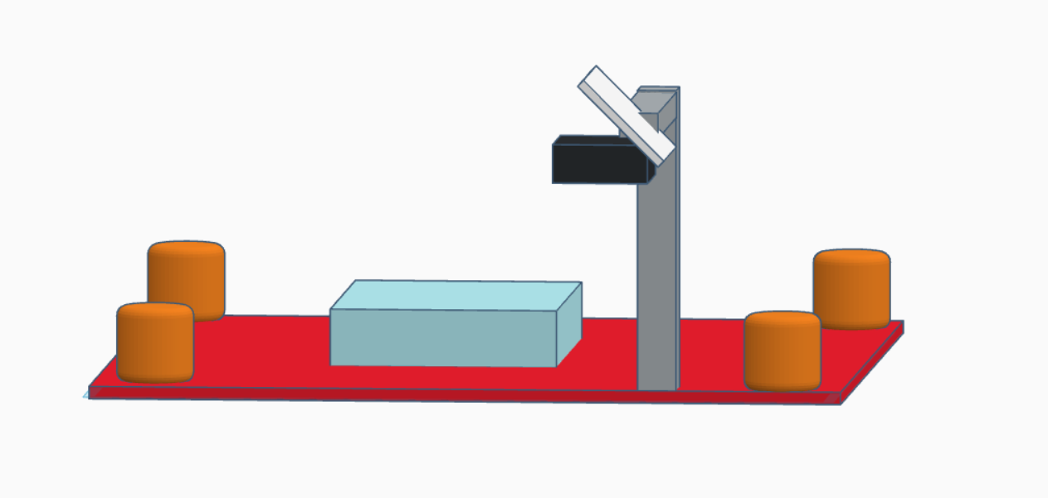  Figure 1: Tinkercad preliminary custom chassis concept for outdoor crop monitoring robot  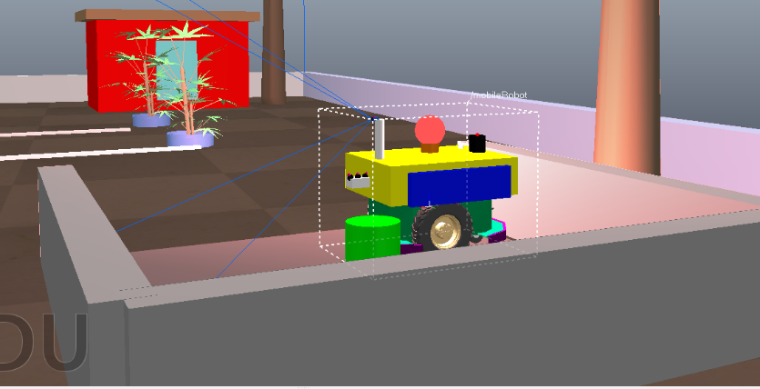  Figure 2: Robot at possible charging station  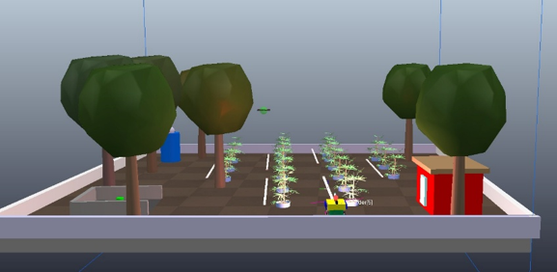  Figure 3: Artist impression the environment the robot would be operating in  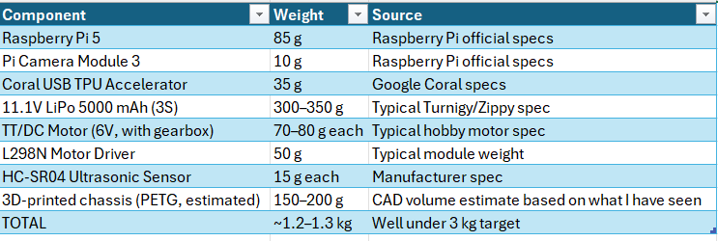  Figure 4: The estimated weight of all the component  Quality and Regulatory issued to be addressed  Electrical Safety: System might operate at 11.1V LiPo (below 30V threshold). No mains voltage exposure. Low risk.  Mechanical Safety: Robot mass < 5 kg, maximum speed < 0.5 m/s. No rotating blades or pinch points.  Mechanical Safety (updated): Custom 3D-printed chassis must be tested for structural integrity under load. Sharp edges from printed parts to be sanded/fillet added. Wheel guards to prevent entanglement. No risk assessment required beyond standard lab induction.  Environmental: Outdoor operation limited to dry conditions; IP rating not required for lab/greenhouse phase. No hazardous fluids or chemicals.  Data/Ethics: No human subjects. If photographing real farm fields, ensure owners’ consent. Plant images are non-sensitive, but GPS-tagged data should be stored securely if representing a real commercial farm.  Standards: No mandatory CE/ISO compliance for prototype stage, but design will follow ISO/TS 15066 collaborative robot principles for force/speed limits as best practice.

